

UNIVERSITI TUNKU ABDUL RAHMAN

FACULTY OF INFORMATION AND COMMUNICATION TECHNOLOGY

KAMPAR CAMPUS

# **UCCD3243 SERVER-SIDE WEB APPLICATIONS DEVELOPMENT**

INDIVIDUAL ASSIGNMENT

**Yong Siew Fung**

**2201805**

**Almighty Soccer**

**Practical 1**

**CN**

**1 September 2023**

|  |  |  |
| --- | --- | --- |
| **Attribute** | **Actual Marks** | **Marks Awarded** |
| **Report Section** | | |
| Analysis – Application Level – UML Diagrams | **10** |  |
| Design – Functional Requirements | **5** |  |
| **Application Section** | | |
| Application – Functional Requirements | **15** |  |
| Application – Design/Architecture | **15** |  |
| Overall Quantity and Quality | **15** |  |
| **Total** | **60** |  |

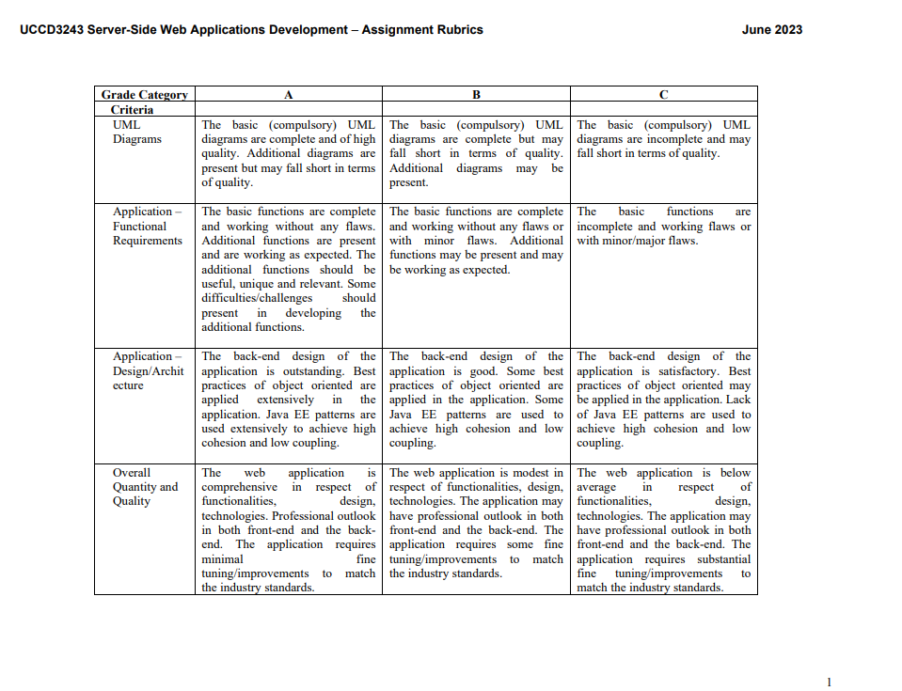

UML DIAGRAMS

Design/Architecture

NOTE: CREATED WITH HTML FILE THEN TRANSLATED THE CODE TO JSP

**THE JAVA SERVLET SUCCESSFULLY CONNECTED TO SERVER**

**INDEX**

Clicking on the SUBSCRIBE button will enable push notification from the webpage.

About page

The Download CV button and the Github is interactive. The first button directs users to a direct download link. They can download by CV by clicking the button. While the Github will bring the users to my source code for my web application.

**User login**

This is the page for user login. Only the administrator can perform CRUD operations by retrieving the PostgresSQL then update the live events for the Almighty Soccer events.

The database is managed by PostgresDBMS

